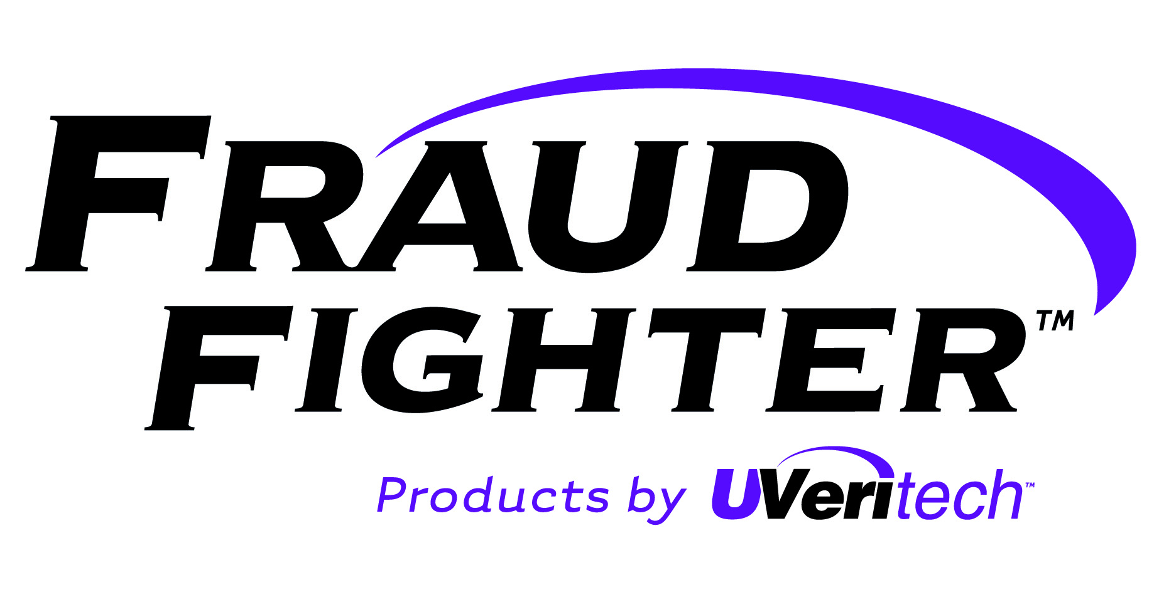
Special User Instructions
AsseTAG Asset Marking Stamps
Development of any new product is often fraught with unforeseen challenges and a need to refine and improve designs in order to achieve marginal improvements to performance and usability. The current project has been no different. While we have successfully solved several of the major challenges, the finer details are still being resolved. Issues such as ink viscosity, porosity of the nibs, and other component-level variables require a process of re-iterating over and over until the proper combinations are found.
As we are still working on discovering the optimal specifications for the AsseTAG product, and since customer feedback is the primary method through which we will be able to ultimately achieve the best-performing design, delivery of the pens in this package has been made before several of these factors could be finalized. As such, we are naming this first batch of pens as “Version 1.1”.
Tips for Usage:
- For optimal performance, the pens should be stored facing downward (i.e. “standing on the caps”) for approximately 1 hour before usage.
- The nibs should be “blotted” prior to using after they have been stored as described in #1. Standing the pens facing downward will cause the ink to heavily saturate the stamping nib, and some excess ink may need to be wiped off in order to obtain clear stamps
- Keep the pen-cap tightly sealed/closed when the pens are not in use.
- Do not store the pens in an area that is above 77 degrees for any extended period. They should be stored in a cool, dry area when possible.
Tips for Stamping:
- It can be difficult to stamp on curved surfaces. If bottles or other curved articles must be stamped, we recommend marking either the cap or the bottom surface.
- The UV fluorescence is blue in color. It will be very difficult to see the mark if it is made on top of white or blue surfaces.
- The ink resistance to solvents varies according to what surface is being marked. Smooth glass or other non-porous surfaces (ceramic, porcelain) will have the least resistance to removal compounds. On these types of products we recommend, if possible that you mark the paper label or other packaging elements (cardboard, plastic) that are not glass.
- Curing time for the ink is as follows:
  - Dry to touch: 30 mins
  - Dry to hardness (solvent resistance) within 24 hours @ 77+ degrees.

